COURSE NAME: Theory of Computation COURSE CODE: CSA1304

COURSE OUTCOME COVERED

CO3:Construct regular expressions, and use the pumping lemma and closure properties to analyze regular languages. (BL : 3)

Assessment Tool Weightage: 20%

QUESTIONS: 5 Total Marks:25
Duration: 1 Hour

CASE STUDY

Code of Conduct:

I M.srivarsha -192371010 (Name / Reg No) certify that this submission is my original work and that I have adhered to the guidelines specified for this assessment.
I understand that any violation of academic integrity rules will result in disciplinary action.

Signature of the student:M.srivarsha

- Designing a Grammar for Arithmetic Expressions
A compiler development team is creating a parser for a calculator application that supports addition, subtraction, multiplication, division, and parentheses. The initial grammar produces ambiguity for expressions such as a+b*c.
Case Study Question:
Develop an optimized context-free grammar (CFG) that correctly enforces operator precedence and associativity for the given arithmetic expressions. Explain how your grammar removes ambiguity and supports efficient parsing.

- Mini Programming Language Parser Development
A startup is designing a small scripting language for automating IoT devices. The language supports variable declarations, conditional statements, and loops. However, the parser frequently reports syntax conflicts during compilation.
Case Study Question:
Construct a CFG for the scripting language constructs below and optimize it to eliminate left recursion and reduce parsing conflicts. Demonstrate how the optimized grammar improves parser efficiency.

- Grammar Optimization for SQL Query Validation
A database company is developing a query validation tool for simplified SQL commands such as SELECT, FROM, and WHERE. The original grammar contains redundant productions that increase parsing time.
Case Study Question:
Develop a CFG for simplified SQL query syntax and optimize the grammar by removing unnecessary productions and ambiguity. Discuss how the optimized grammar helps in faster syntax analysis.

- Natural Language Processing Chatbot
A chatbot system processes simple English sentences such as:
Subject + Verb + Object
Example: “Students learn TOC.”
The initial CFG incorrectly accepts grammatically invalid sentences.
Case Study Question:
Design a CFG for the chatbot sentence structure and optimize it to improve language validation accuracy. Explain how the grammar ensures correct sentence formation and rejects invalid inputs.

- Parser Design for HTML-like Markup Language
A web editor company is building a parser for a simplified markup language with opening and closing tags. The existing grammar fails to validate nested tags correctly.
Case Study Question:
Develop and optimize a CFG for validating properly nested tags in the markup language. Show how the grammar supports recursive nesting and improves parsing reliability.

Question 1 — Designing a Grammar for Arithmetic Expressions
A compiler development team is creating a parser for a calculator application that supports addition, subtraction, multiplication, division, and parentheses. The initial grammar produces ambiguity for expressions such as a + b * c.
Task: Develop an optimized context-free grammar (CFG) that correctly enforces operator precedence and associativity for the given arithmetic expressions. Explain how your grammar removes ambiguity and supports efficient parsing.

1.1 The Ambiguous Grammar
The naive grammar treats every operator identically:
E → E + E | E − E | E * E | E / E | ( E ) | id
For the string a + b * c, this grammar produces two different parse trees — one where + is applied last (correct precedence) and one where + is applied first (incorrect). Because two distinct leftmost derivations exist for the same string, the grammar is ambiguous.

1.2 The Optimized, Unambiguous CFG
Ambiguity is removed by introducing separate non-terminals for each precedence level and forcing left recursion, which naturally encodes left-associativity:
E → E + T | E − T | T (lowest precedence: + and −)
T → T * F | T / F | F (middle precedence: * and /)
F → ( E ) | id (highest precedence: parentheses / operand)
- E (Expression) handles addition and subtraction.
- T (Term) handles multiplication and division, and is reachable only through E, so * and / always bind tighter than + and −.
- F (Factor) handles parenthesised sub-expressions and atomic identifiers, which have the highest precedence of all.
- The left-recursive rules E → E + T and T → T * F force operators of the same precedence to associate to the left, matching standard arithmetic evaluation order.

1.3 Parse Tree for a + b * c
With the optimized grammar there is exactly one parse tree for a + b * c — multiplication is nested one level deeper than addition, so it is evaluated first:
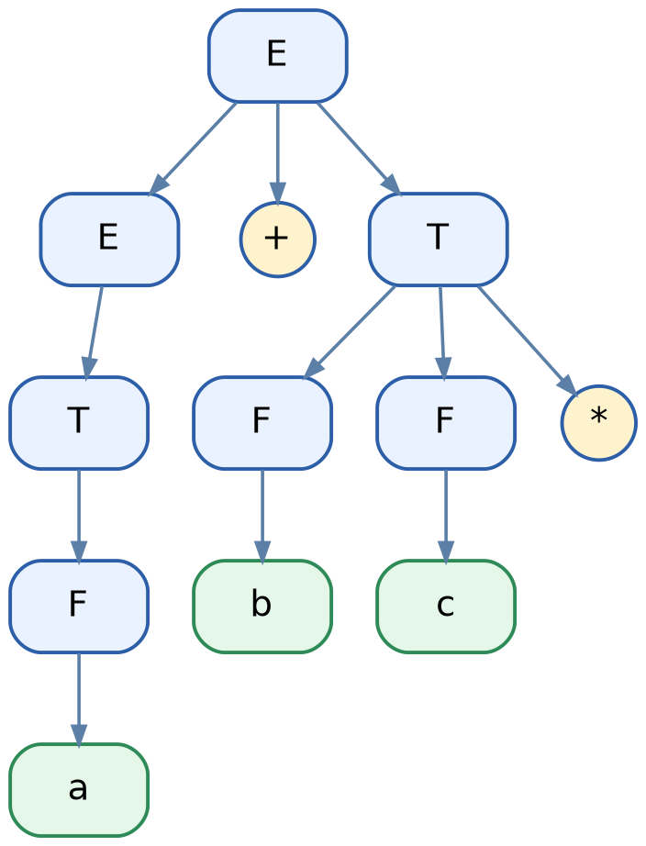
Figure 1.1 — Unique parse tree for a + b * c under the optimized CFG

1.4 Why This Removes Ambiguity and Aids Parsing
- Each precedence level has its own non-terminal, so the grammar structure itself encodes precedence — no external precedence table is needed at parse time.
- Because every non-terminal has an unambiguous production for each operator, only one derivation tree exists per valid string, satisfying the definition of an unambiguous grammar.
- The layered structure (E → T → F) maps directly onto a recursive-descent parser, where each non-terminal becomes one parsing function, giving efficient O(n) parsing for expressions of length n.
- Left recursion in E and T correctly encodes left-associativity (e.g., a − b − c is parsed as (a − b) − c).

Question 2 — Mini Programming Language Parser Development
A startup is designing a small scripting language for automating IoT devices. The language supports variable declarations, conditional statements, and loops. However, the parser frequently reports syntax conflicts during compilation.
Task: Construct a CFG for the scripting language constructs below and optimize it to eliminate left recursion and reduce parsing conflicts. Demonstrate how the optimized grammar improves parser efficiency.

2.1 Initial CFG for the Language Constructs
Program → StmtList
StmtList → StmtList Stmt | Stmt
Stmt → Declaration | Conditional | Loop
Declaration→ var id = Expr ;
Conditional→ if ( Expr ) { StmtList } else { StmtList }
Loop → while ( Expr ) { StmtList }
Expr → Expr relop Expr | id | num
Two problems appear here: (1) StmtList → StmtList Stmt is left-recursive, which makes a recursive-descent / top-down parser loop forever; (2) Expr → Expr relop Expr is also left-recursive and ambiguous for chained comparisons.

2.2 Eliminating Left Recursion
Using the standard left-recursion elimination transformation (A → Aα | β becomes A → βA', A' → αA' | ε):
StmtList → Stmt StmtList'
StmtList' → Stmt StmtList' | ε

Expr → Term Expr'
Expr' → relop Term Expr' | ε
Term → id | num
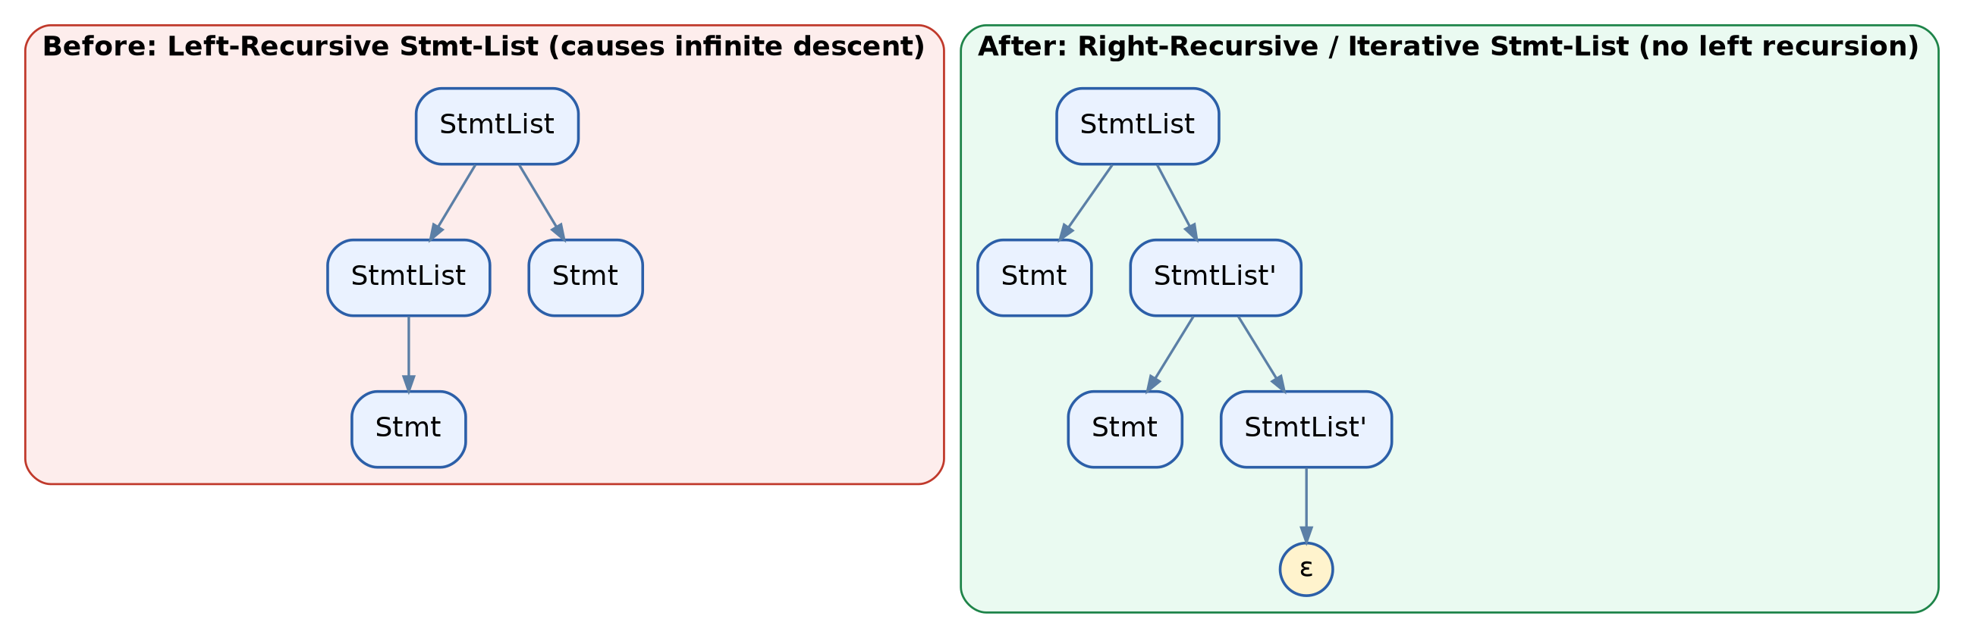
Figure 2.1 — Left-recursive StmtList (left) restructured into an equivalent right-recursive form (right), removing the infinite left-descent path

2.3 Optimized Complete CFG
Program → StmtList
StmtList → Stmt StmtList'
StmtList' → Stmt StmtList' | ε
Stmt → Declaration | Conditional | Loop
Declaration → var id = Expr ;
Conditional → if ( Expr ) { StmtList } else { StmtList }
Loop → while ( Expr ) { StmtList }
Expr → Term Expr'
Expr' → relop Term Expr' | ε
Term → id | num

2.4 How This Improves Parser Efficiency
- Left-recursion elimination allows a predictive (LL) recursive-descent parser to terminate correctly instead of entering unbounded recursion on StmtList and Expr.
- Each Stmt alternative (Declaration, Conditional, Loop) begins with a distinct keyword (var, if, while), so the parser can select the correct production using a single lookahead token — this is what removes the 'syntax conflicts' the startup observed.
- The grammar is now suitable for table-driven LL(1) parsing, which parses in linear time O(n) and reports precise syntax errors at the point of failure, rather than backtracking through an ambiguous grammar.
- Because Conditional explicitly binds each if with its own else inside braces, the grammar also avoids the classic 'dangling-else' conflict.

Question 3 — Grammar Optimization for SQL Query Validation
A database company is developing a query validation tool for simplified SQL commands such as SELECT, FROM, and WHERE. The original grammar contains redundant productions that increase parsing time.
Task: Develop a CFG for simplified SQL query syntax and optimize the grammar by removing unnecessary productions and ambiguity. Discuss how the optimized grammar helps in faster syntax analysis.

3.1 Original (Redundant) Grammar
Query → SelectStmt
SelectStmt → SelectClause FromClause WhereOptClause
SelectClause → SELECT ColumnList | SELECT ColumnList
WhereOptClause → WhereClause | WhereClause | ε
ColumnList → Column | Column , ColumnList | Column
WhereClause → WHERE Condition
This grammar has duplicate, functionally identical alternatives (e.g., SelectClause has the same production listed twice; WhereOptClause repeats WhereClause), which forces the parser to needlessly compare extra alternatives before choosing a production.

3.2 Optimized CFG
Query → SELECT ColumnList FROM Table WhereClause
ColumnList → Column ColumnList'
ColumnList' → , Column ColumnList' | ε
WhereClause → WHERE Condition | ε
Condition → id relop Value
relop → = | <> | < | > | <= | >=
Column → id | *
Table → id
Value → id | num
Redundant duplicate alternatives are removed, and the comma-separated column list is rewritten without left recursion using ColumnList', matching the same optimization technique used in Question 2.

3.3 Parse Tree for SELECT name FROM students WHERE age > 20
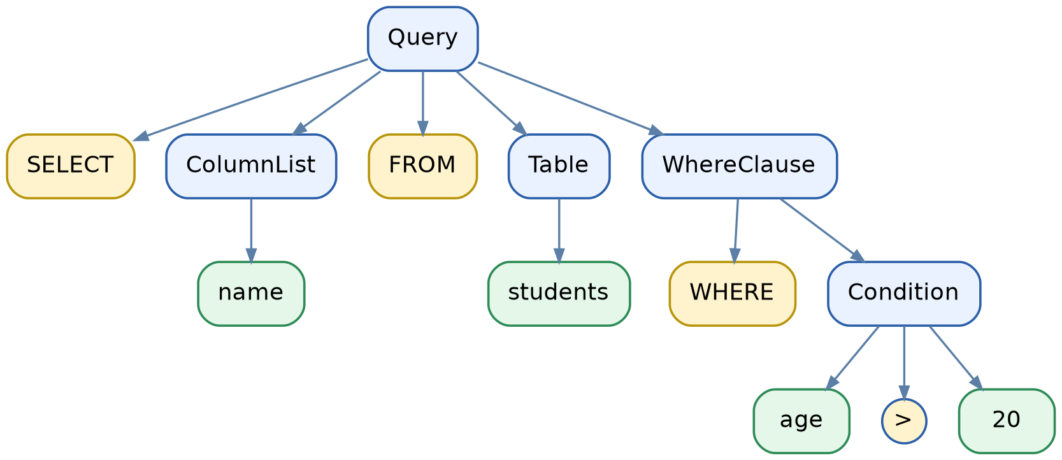
Figure 3.1 — Parse tree for the optimized SQL grammar on a sample query

3.4 Why the Optimized Grammar Is Faster
- Removing duplicate productions shrinks the number of alternatives the parser must try at each decision point, directly reducing the branching factor of the parse table.
- A single, deterministic production per clause (SELECT … FROM … WHERE …) allows one-token lookahead to pick the correct rule, enabling LL(1) / recursive-descent parsing in linear time.
- Making WhereClause optional via ε (instead of duplicated alternatives) cleanly models that WHERE may or may not appear, without adding redundant grammar rules.
- Fewer productions also means a smaller parse table and less memory overhead in the validation tool, which matters when validating queries at scale.

Question 4 — Natural Language Processing Chatbot
A chatbot system processes simple English sentences such as Subject + Verb + Object, e.g. “Students learn TOC.” The initial CFG incorrectly accepts grammatically invalid sentences.
Task: Design a CFG for the chatbot sentence structure and optimize it to improve language validation accuracy. Explain how the grammar ensures correct sentence formation and rejects invalid inputs.

4.1 Initial (Overly Permissive) Grammar
Sentence → Word Word Word
Word → Students | learn | TOC | quickly | the | run
Because Word can appear in any of the three positions, this grammar also accepts nonsensical strings such as “quickly the run” or “TOC TOC TOC”, since it only checks word count, not grammatical role.

4.2 Optimized CFG with Grammatical Roles
Sentence → Subject VerbPhrase
VerbPhrase → Verb Object
Subject → NounPhrase
Object → NounPhrase
NounPhrase → Noun | Article Noun
Noun → Students | teachers | TOC | grammar
Verb → learn | teach | study
Article → the | a
Each terminal is now assigned to a specific part-of-speech non-terminal, and Sentence enforces a fixed structural order: Subject, then VerbPhrase (which itself expands to Verb + Object). A word can only occupy the syntactic role its category permits.

4.3 Parse Tree for “Students learn TOC”
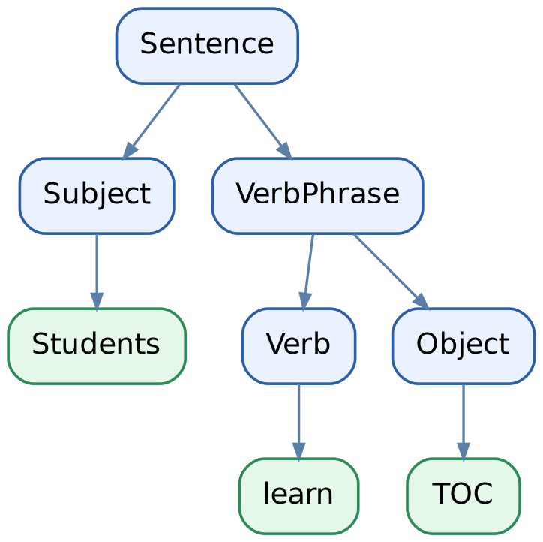
Figure 4.1 — Parse tree confirming Students (Subject) + learn (Verb) + TOC (Object)

4.4 How This Improves Validation Accuracy
- Separating Noun, Verb, and Article into distinct non-terminals means the grammar rejects role-violating strings such as “TOC learn Students” or “quickly the run”, since quickly is not defined under any category the grammar accepts in that position.
- The fixed rule Sentence → Subject VerbPhrase enforces Subject–Verb–Object word order, which is the correct structure for the target language fragment.
- Restricting the vocabulary of each category (e.g., only real verbs under Verb) prevents category-mismatched sentences from being derived at all, directly fixing the false-acceptance problem described in the case study.
- Because the grammar is unambiguous and each non-terminal has clearly separated alternatives, the chatbot's parser can validate a sentence in linear time and pinpoint exactly which word/category caused a rejection.

Question 5 — Parser Design for HTML-like Markup Language
A web editor company is building a parser for a simplified markup language with opening and closing tags. The existing grammar fails to validate nested tags correctly.
Task: Develop and optimize a CFG for validating properly nested tags in the markup language. Show how the grammar supports recursive nesting and improves parsing reliability.

5.1 Faulty Grammar
Document → OpenTag Content CloseTag
Content → text | OpenTag Content CloseTag
OpenTag → < id >
CloseTag → < / id >
Because OpenTag and CloseTag do not carry the actual tag name through the grammar (id is just a generic terminal), this grammar cannot verify that a closing tag matches its corresponding opening tag — it would incorrectly accept malformed markup like <div>text</p>.

5.2 Optimized CFG for Properly Nested, Matching Tags
Document → Element
Element → OpenTag Content CloseTag
Content → Element Content | Text Content | ε
OpenTag → < TagName >
CloseTag → </ TagName >
TagName → div | p | span | body
Text → text
Note: to fully enforce that a CloseTag's name matches its OpenTag's name, a context-free grammar must be extended with semantic (attribute) checks, since strict tag-name-matching (anbn-style agreement) is not always expressible by a single CFG production alone; the structural nesting itself, however, is fully captured below and is the core recursive property being modeled.

5.3 Parse Tree for <div><p>text</p></div>
The rule Content → Element Content allows an Element (a tag pair) to be nested inside another Element's content, and this rule can apply recursively to any depth — this is exactly how balanced, nested tags are modeled, analogous to the classic anbn nested-parentheses language:
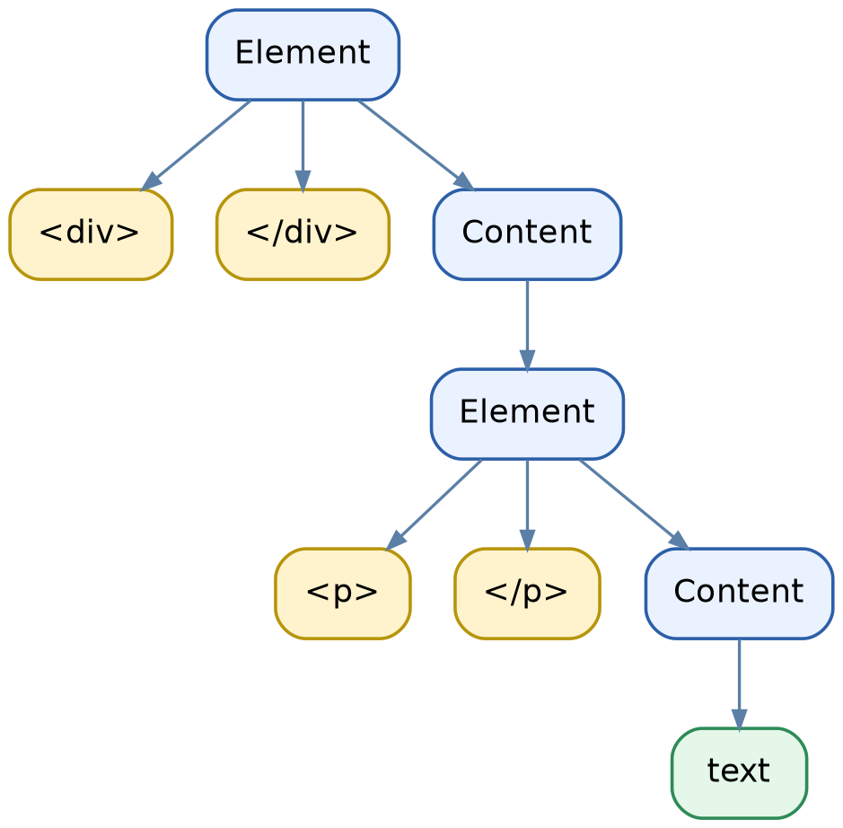
Figure 5.1 — Parse tree showing <p>…</p> recursively nested inside <div>…</div>

5.4 Why This Grammar Supports Reliable Nested Parsing
- The recursive rule Element → OpenTag Content CloseTag, combined with Content → Element Content, allows tags to nest to any depth, which correctly models arbitrarily deep HTML-like structures.
- Every Element production explicitly pairs one OpenTag with one CloseTag, so structurally the grammar only derives balanced tag pairs — an unmatched opening or closing tag cannot be generated by this grammar.
- The ε alternative in Content cleanly terminates the recursion for empty or leaf elements, avoiding the ambiguity/looping issues of the original grammar.
- Because nesting is expressed through recursive non-terminals rather than a flat token count, a recursive-descent parser can validate nesting depth and structure in a single linear pass, improving both reliability and performance over the faulty grammar.

RUBRICS FOR CALCULATION:

Criteria | Weightage | Level 4 – Exemplary (5 Marks) | Level 3 – Proficient (4 Marks) | Level 2 – Developing (2–3 Marks) | Level 1 – Beginning (0–1 Mark)
Conceptual Understanding | 30 | Demonstrates clear and complete understanding of the concept | Good understanding with minor gaps | Basic understanding with some misconceptions | Poor or incorrect understanding
Accuracy of Answer | 25 | Completely correct answer with no errors | Mostly correct with minor errors | Partially correct with noticeable errors | Incorrect or irrelevant answer
Application of Knowledge | 20 | Correctly applies concepts to solve the question/problem | Applies concepts with minor mistakes | Limited or partially correct application | No or incorrect application
Completeness of Response | 15 | Covers all required parts of the question | Covers most parts with minor omissions | Covers only some parts | Incomplete or missing response
Clarity & Presentation | 10 | Clear, concise, and well-organized answer | Understandable with minor issues | Somewhat unclear or poorly structured | Difficult to understand

